**Cover Page**

**Table of Contents**

**Executive Overview**

**Activity A**

* + **Business Context**
    - How does it relate to the business?
  + **User needs**
    - Who is going to use the product
    - How are they going to use the product (decomposition of problems)
      * Functional Requirements (Epics)
      * Non-Functional Requirements
  + **Research**
    - **Existing Solution A**
      * (Description
      * How it uses hardware/software
      * Strengths/weaknesses and how it applies to user needs)
    - **Existing Solution B**
      * (Description
      * How it uses hardware/software
      * Strengths/weaknesses and how it applies to user needs)
    - **Existing Solution C**
      * (Description
      * How it uses hardware/software
      * Strengths/weaknesses and how it applies to user needs)
    - **Emerging Technologies**
      * (Potential technologies and how they could apply to user needs)
    - **Industry Guidelines and Best Practices**
  + **Assumptions**
    - (What information/resources are we assuming for this project

**Activity A.2**

**Design Proposal**

* + - **Overview** (Description and Justification)
    - **Potential Design Options**
    - **Selected Design Option**
    - **Functional Requirements Expanded**
      * Functional Requirement #1
      * Functional Requirement #2
      * Functional Requirement #3
    - **Justification**
    - **Non Functional Requirements Expanded**
      * **Examples:**
      * Performance
      * Safety
      * Security
      * Quality
    - **Technical requirements** 
      * Personnel
      * Software requirements
        + Development requirements
        + Technologies (I.E. libraries used)
      * Hardware requirements
        + Development requirements
        + Production requirements
    - **Project Management Mythology**
      * **Project Key Performance Indicators**
* **Activity B**
  + **Visual/Interface Designs** 
    - GUI Layouts
    - Wireframes
  + **Data Requirements**
    - List of data collected/how it’ll be stored
  + **Algorithm Designs**
    - flowcharts
    - pseudo code
  + **Test Strategy Table**
* **Citations**

**Executive Overview**

Toka Fitness is in need of a new digital solution which would help their company out to communicate with their existing and coming customers as well as helping their employees on completing the tasks. At the moment Toka Fitness currently provides customers with; **personal training sessions, advice about fitness training and advice about healthy living**. But they are now in need of features such as:

* **provide information and advice about fitness training and healthy living**
* **provide access to digital content to support customers with their training and healthy lifestyle**
* **encourage existing customers to use more of the services provided by Toka Fitness**

Toka Fitness has also carried out market research with existing customers to identify potential features which could be included in the digital solution. Potential features included items such as:

* **free and paid-for content**
* **accessibility features for users with sight loss**
* **‘social’ features**
* **customisable workout and eating plans**

As a result of this, the features they required can be completed and will be done by the time they expect this solution to be completed.

**Activity A**

**Business Context**

**How does it relate to the business?**

Toka fitness is in need of a digital solution which would keep their existing customers happy with different features as well as wanting a way to attract potential customers. This can be seen through requested feature such as **‘social’ feature** as by having this and ability to communicate or post information online can attract new customers and try Toka Fitness products.

**User Needs**

**Who is going to use the product**

By Toka’s description the digital solution would be used by their current employees and existing customer as well as potential new customers in the future. However, this is mostly targeted to attract and keep customers by the requested features from both parties. This can be seen through suggestions such as :

* **‘social’ features (existing customer)**

**>** This may indicate things such as chat boxes or a way to share your workout results or your progress with everyone else

* **encourage existing customers to use more of the services provided by Toka Fitness(owner of TokaFitness)**

**>** This suggest that there should be a way to have access to more content once you become a member of the community or have additional buy on features.

* **Free and paid-for content**

**>** indicated solution should contain a way to upgrade from free content to premium or paid-for content which gives customers many more features to access.

All these requirements may indicate that Toka and their customers are wanting a solution which they can interact with and get extra content buy having their content bought by things such as having different member ships or just buying the feature to have access to.

**How are they going to use the product (decomposition of problems)**

By the information given by the client the desired solution should be interactive with features they have requested. I will make sure to include their Functional requirements which are stated by Toka Fitness and include potential non-functional requirements suggested by existing customers

* Functional Requirements (Epics)

the client has requested features such as:

* + **provide information and advice about fitness training and healthy living**

**>** As customer I would like to see information about training and healthy living.

**>** I want to see images and a way to interact with the information through ways such as scroll wheel or read more buttons

* + **provide access to digital content to support customers with their training and healthy lifestyle**

**>** As customer i would like to receive supportive messages and ways on improving my lifestyle

**>**

* + **encourage existing customers to use more of the services provided by Toka Fitness**

**>** As an existing customer I would like to have access to more services/ features provided by Toka Fitness.

* + **free and paid-for content**

**>** As a customer I want to be able to have access to Free content

> As a customer I want to be able to buy additional content and have access to it

* + **accessibility features for users with sight loss**

**>**as a customer I want a way to access different features with sight loss

* + **‘social’ features**

**>** As a customer I want to share my progress with other people

**>** As a customer I want to see other people’s progress

* + **customisable workout and eating plans**

> As a customer I want to have an option to edit my workout plan

> As a customer I want to have an option to edit my eating plan

* Non-Functional Requirements

Security

As we will be storing customer data it is important to make sure that their data is stored in a safe location in some sort of database system or file.

Performance

When creating the product, we have to make sure everything works as its suppose to such as buttons or any interactive interface produces something visual for the user

Safety

As the user will be entering their own personal details, we need to make sure they cannot be seen by anyone else or accessed. This may include having login systems where only the customer has access to their account and no one else.

Quality

User experience is the most important part of this project as it will be seen by the user , and we want to leave good impression by having everything working and looking good ( colours , functions, pages).

**Research**

[](https://sworkit.com/)(1)

Description

Sworkit is a premium digital health and fitness company. They provide workouts, customizable plans, and resources which help people to take in continue the good habits for life. They also have a custom combination of strength, cardio, yoga and stretching workouts. Sworkit also have an App which contains mostly workouts with videos on how to complete them. The App allows people to Personalize your workouts, recommends you a workout plan based of your goals and gives support by answering your fitness and nutrition question.

How it uses hardware/software

* Can be bought on iPhone
* Can be bought on Android
* Available on Websites
* internet

Strengths/weaknesses and how it applies to user needs

**Strengths**

* Is available to many platforms such as Mobile and web based.
* allows you to customise your own workout plan
* allows you to customise your own meal plan
* supports you with questions you may have
* Blogs

**weakness**

* no easy option to share your progress
* videos freeze / not work

Overall Sworkit has many features which are desired by Toka Fitness including cross platform access such as Mobile(iPhone & Android and web based which covers a wide range of potential customers which can be targeted. Their customisable workout plan can be a potential feature included in my potential solution as it gives customers access to personalise their apps.

(2)

Description

C25K is made for beginner runners to achieve 5k running in 8 weeks. They have features such as Audio Coach which alerts you when to walk or run. It has a music playlist for you to listen to which can increate motivation by 35%. They have inspirational transformation with images on their website which people can share their progress with on how well they are doing using this app.

How it uses hardware/software

* can be downloaded on iPhone
* can be downloaded on Androids
* Accessible through web
* internet

Strengths/weaknesses and how it applies to user needs

**strengths**

* has a lot of content and premium content which can be bought
* allows people to listen to audio such as music
* targeted at any fitness level

**weaknesses**

* not ideal for people trying to lose weight.
* cannot personalise workouts
* doesn’t include meal plans

Overall C25K is made for people who only want to get into running and is great program for someone who just got into fitness and is a complete beginner. It however doesn’t have any meal plans or any other exercises which can be chosen as their aren’t much of customisable content. However, it does have a feature which Toka Fitness may like such as having more access to different content by buying additional features, this links great to one of the requirements Toka is wanting as a free and paid-for content. As a result, this feature to get more content from buying can be used in my solution on requirement the existing customers have suggested.

(3) MyFitnessPal

Description

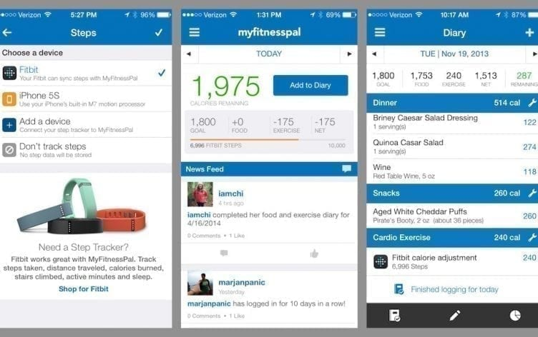MyFitnessPal is a Smartphone app & web application which allows you to track what you eat. It has features such as food diary which helps you keep a track of item’s you have eaten in a log. Scanning barcodes for use of fast and easy food tracking. As well as having a large community which you have share your progress with and receive support 24/7

How it uses hardware/software

* internet
* Mobile applications
* web applications

Strengths/weaknesses and how it applies to user needs

Strengths

* Heavily based on tracking calories and food items you have eaten
* has ability to share content with other people
* has blog page to read more information about food items
* scanning meals or food items for tracking

Weaknesses

* doesn’t have as much exercises to do
* too much time consuming
* incorrect calories/macros not always available.

Overall MyFitnessPal is great for healthy lifestyle in terms of diet based and healthy eating as it has many features to help you track what you eat and saving it in a logbook when you can look back on what you eaten. The most stand out feature is the calorie tracking as it allows people to see what they have eaten thought the day. I would like to use this feature as it exactly what Toka Fitness is looking for in terms of healthy lifestyle as it allows people to have a good diets by letting them decide what they want to eat but still having a main goal of amount of calories they should reach by the end of it.

**Emerging Technologies**

Potential technologies and how they could apply to user needs

Internet of Behaviours (IoB) (4)

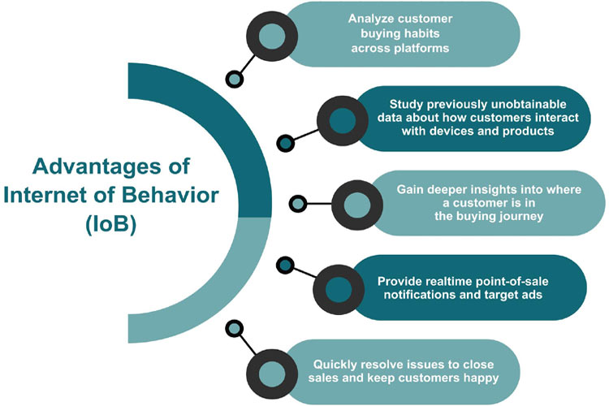

Internet of Behaviours ( IoB ) is used by big businesses who use analytics and big data techniques to determine the data’s value in what is know as IoB. By Reviewing customer information businesses can personalize their services, market their products, and improve customers experience with the company and potentially being able to attract more customers. However down sides to this is that is companies are battling users to share personal data with them to develop the solutions due to having to first obtain the user data in some way. Customers feel uncomfortable about risking their privacy in return of services due to website hacking and other cybersecurity challenges.

IoB is important to industry sectors such as:

* E-commerce
* health care
* Customer experience
* management
* Search engine optimization

IoB potential uses are:

* Reducing insurance premiums for drivers who have expensive vehicles which are more desired to brake into and IoB can see the patterns for it
* Examining peoples grocery purchases in order to alter and personalize menu suggestions to the person
* sending alerts to fitness activity trackers when it detects wearer’s blood pressure is too high or too low

IoB would be a great asset for Toka Fitness as they would be able to suit their workouts and meal plans more accurately depending on customers data gathered all over the internet, this could be things they googled in food category or exercise they are mostly interested in. This would give Toka more data to work with and decide what they truly would like to see in their digital solution as this would maximise the sales of their products

Virtual Reality (7)

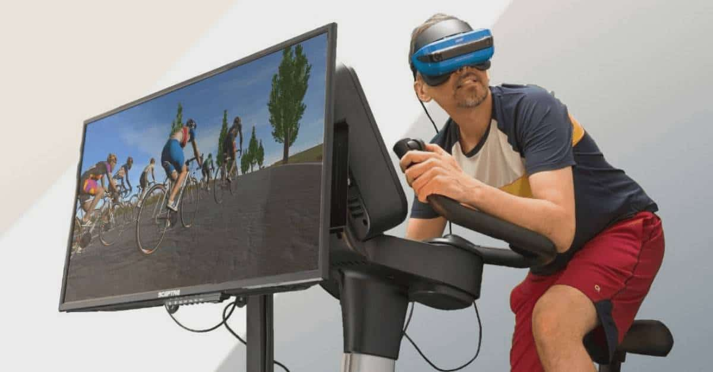

Virtual reality is an emerging technology which is out and is getting used by many companies in different industries. The latest technology is working in Health and Fitness and getting introduced to gamers and engaging them to be active and exercise while playing games. This encourages many people workout from anywhere even comfort of their homes. VR is a great way to be used within the fitness industry as it targets a wider range of audience who may be disabled and cannot go and workout in places such as gyms or have specific equipment to. Toka Fitness would benefit of using VR as an upcoming technology in their business as it would allow them to reach a wider range of people who are not into fitness. This would also benefit them in having this unique technology which nobody else has in this industry making them stand out from any other company and attacking more people.

**Accessibility**

To make Toka Fitness stand out from all other competitors ill make sure to cover all accessibility options such as:

* Using colour with care
* giving buttons unique name which describe what they do
* having text the same font
* having forms labelled appropriately
* ensure all content can be clicked or accessed with keyboard

**Industry Guidelines and Best Practices (6)**

GDPR

GDPR is the toughest privacy and security law in the world. It imposes obligations onto organizations anywhere, so long as they target or collect data related to people. GDPR will give out harsh fines against organizations who violate privacy and security standards, with penalties reaching into the tens of millions of euros.

As this project will most likely involve storing data in some way or form, I will have to make I follow all GDPR rules with data protection such as:

* Lawfulness, fairness, and transparency – Processing must be lawful, fair and transparent to the data subject
  + This is about being clear and open about what you are doing with peoples personal data
* Purpose limitation – You must process data for the legitimate purposes and specified explicitly to the data subject when you collected it.
  + This means data collected must be used for a legitimate purpose and not processed further in a way which it’s not required to be used by you
* Data minimization – You should collect and process only as much data as absolutely necessary for purposes specified
  + This means you should not request more information from a person than necessary for your business
* Accuracy – You must keep personal data accurate and up to date
  + This is about making sure all customer information is correct and is up to date
* Storage limitation – You may only store personally identifying data for as long as necessary for the specified purpose
  + This means when your business no longer requires the customers data or if its not being used you must remove it as its no longer used for its purpose
* Integrity and confidentiality – Processing must be done in such a way as to ensure appropriate security,inegrity and confidentiality.
  + This means any data collected from the user must be kept as secure as you can through ways such as encryption and storing in high secure databases with little access to them
* Accountability – The data controller is responsible for being able to demonstrate GDPR compliance with all the principles
  + This means people who have access to the sensitive data will be held accountable if anything happens to it

With these rules from GDPR set in place i will need to consider factors such as how i will store customers sensitive data and who will have permission to view it and access it. If the user is no longer active with Toka Fitness their personal details will have to be removed as we no longer will have purpose for it being stored in the database. When requesting users for their information i must only request the only data which is absolutely necessary for purpose of using in future. To make sure customer are keeping their data up to date or the same, form will pop up asking if user has changed any information or if its kept the same. The data collected from the users will be confidentiality stored in the database with little to no access by any employee or staff member so it cannot be stolen else we will be held accountable for it.

Toka Fitness will have to make sure to train their employees on how to handle customer data so there aren’t any issues happening in the future.

Best Practices

* Training Employee’s with the system and how to operate data
  + Having employees with knowledge of how to operate the system is key as they will know in and outs of it. This is good in case they are struggling and don’t understand how data is getting managed and if untrained may lead to data being leaked which is a very bad scenario as GDRP will get involved with its data protection
* Having backups of data
  + Having backups of data is import in case when developing the solution in the future developer wipes out the entire database worth of data it can be rolled back. However, if there isn’t a backup you may be in trouble as you have lost all the customer data which once again links back to GDPR and potential big fines
* Have encrypted data
  + Password encryption for data is a good way of keeping it all safe in case the data does get leaked it can be accessed as easily by an outsider who doesn’t know the password to it. If data isn’t encrypted and gets interrupted between two users and stolen without anyone knowing which is very bad.
* Use Strong passwords
  + When creating accounts, you should use strong passwords with different characters and symbols. This is necessary as it would make it difficult for anyone else to guess your password within minutes. Adding more characters or using even pass phrases can make your accounts password un guessable as fast. As a result of this when we are collecting customers data, we will require them to have a specific amount of characters and special cases used in it to make it harder to be guessed
* Don’t keep data for longer than needed
  + When we are storing data, we will need to make sure any previous data of the user is still correct by updating it. If the user has decided to leave or no longer use our product, we will remove them from the data base as it’s no longer used for its intended purpose as would be a waste of space.
* have good anti-malware
  + Anti-malware systems are very import for businesses which handle data as you don’t want your data getting hacked into and leaking all the data. If this does happen it will bring consequences from GDRP as well as it would bring bad reputation to our business making people no longer use our products as they would be scared their data can be leaked or stolen.

**Assumptions**

* I assume Toka Fitness is specialised in Health and Fitness Industry as their potential features relate to that industry sector
* I assume Toka Fitness has more than 1 employee working for their company
* I assume Toka is an Online business and only sells their products online
* I assume Toka has an Excel sheet to store their existing customer data
* I assume Toka has given us a time frame to complete it by however not specified

As Toka Fitness hasn’t explained their brief in more detail I will have to assume some information to make the project development easier. If it would be possible as a software development team we would keep in touch with the client (Toka) and have daily meetings and showcases of what we have done and information we require. Meetings would be essential for this project as i would like to receive as the client would be able to give us feedback on what we have done as well as any potential new requirements they may have.

**Design Proposal**

**Overview** (Description and Justification)

Toka Fitness has requested a digital solution which would cover their key requirements such as:

* **provide information and advice about fitness training and healthy living**
* **provide access to digital content to support customers with their training and healthy lifestyle**
* **encourage existing customers to use more of the services provided by Toka Fitness**

As well as having their existing customers giving them advice on features which could be included in the potential solution being:

* **free and paid-for content**
* **accessibility features for users with sight loss**
* **‘social’ features**
* **customisable workout and eating plans**

This project can be completed within the time frame they want it to be done by with many of the features included in the digital solution. I have decided that the solution will contain unique features from the research I have done and I’ll try to include the components i liked the most which match the functional requirements of Toka & their existing customers.

**Potential Design Options**

Thought the research gathered there was a common 2 platforms where fitness and lifestyle were most popular and they there either Web based or App for mobiles. As a result, there are 2 potential options which I can pick from doing, as a result of this it gives more flexibility on which choice is better by end of the decisions process.

Web based

Web based application would be a great way to display many features which Toka is in need of and also have their previous features. Web based would be best option as being cross platform based meaning it can be accessed by any device. As well as Main benefit of being web based is not having version control and all users being able to access the same version eliminating any compatibility issues.

|  |  |
| --- | --- |
| Strengths of using Web based app | Weaknesses of using Web based app |
| * cross platform compatibility | * internet dependences |
| * easier to update | * web issues (hosting) |
| * customization |  |
| * not needed to be installed |  |
| * access thought multiple browsers |  |

*conclusion*

In conclusion I believe using a web-based application is the best option to proceed with this project as it has a lot of strengths and gives more benefits on all of the designing part of the project and having good user interface is key for this project. There are a lot of opportunities to make website more functional that apps as I will be able to do all the jobs Toka has asked and potentially adding some unique features. If Toka do decide to develop the solution further in the future by adding new features or designs they will be able to do it as the code would be well maintained and wouldn’t require as much maintenance on the website.

App (Mobile)

App is good in its own ways such as improving customer loyalty through making them download the application as a result of this the application would be on their phone which can be easily accessed any time of day.

|  |  |
| --- | --- |
| Strengths of using App( mobile) | Weaknesses of using App (mobile) |
| * Faster | * updates & maintenance is more needed |
| * instant online & offline access | * trouble finding application in the catalogue |
| * device features ( finger to move about / more interactive) | * costs |
| * instant updates / push notifications |  |
|  |  |

*conclusion*

I believe creating a Mobile app is great a good idea however it has limitation which would be hard to overcome. Such as costs, to create and publish an app it will cost as a result of this to get it on each store such as App store or google play i will cost additional money therefore making web-based application more desirable for this project.

**Selected Design Option**

I have decided to go with web-based application for this project as I believe it will be easier to reach the target audience in the health community as well as being able to add all the features the client has requested and making sure existing customers features are also included in this design.

As I have decided to go with a web-based application for Toka Fitness digital solution i will require to use different programming languages such as JavaScript/html/CSS for the front end development. This will be used for creating all the interface designs which the customer will be able to see and use. I chose this as one of my languages as its most commonly used for web development and is updated frequently with new features. For my second language I’m going to use Python as the backend of this solution. With python I will be able to make web calls to post and get pages depending on what’s been clicked on the front end of the website. As Toka hasn’t specified where they store data, I have decided to store it in an excel sheet for the time being. Data such as name ,password ,email and bank details will be stored in the excel sheet.

Requirements such as:

* **provide information and advice about fitness training and healthy living**
* **provide access to digital content to support customers with their training and healthy lifestyle**
* **encourage existing customers to use more of the services provided by Toka Fitness**
* **free and paid-for content**
* **accessibility features for users with sight loss**
* **‘social’ features**
* **customisable workout and eating plans**

Will be easily accomplishable with the way of web-based product by having all the functionality as well as user experience included within. Designing it will also be easier therefore meaning in future if Toka Fitness decide to rebrand their website, it will be much easier for the developer to understand what’s going on.

Things to consider when creating website

Before creating a website for Toka Fitness I will have to consider all the legal items such as:

* The right to use the domain name
* Toka Fitness policies and procedures
* Accessibility of the website
* Respecting copyright
  + If taking any data from internet( pictures, text, links) i will have to ask for permission to use it and credit the creator.
* The rights of user to grant consent for using their data on our website as well as gathering it
* eCommerce transactions & compliance
  + As we will be selling premium feature will have to buy it therefore, they will have to enter their credit card details and there is rules which we must follow.

**Functional Requirements Expanded**

|  |  |  |  |  |
| --- | --- | --- | --- | --- |
| **Task number** | **Functional Requirements in depth** | **User stories ( what user wants to happen)** | **Tasks** | **User Acceptance Criteria for functional requirements** |
| **1a** | **provide information and advice about fitness training and healthy living** | As customer i would like to see information about training and healthy living. | **\***Creating a webpage (main page) | *User should be able to click on blogs webpage |
| **b** |  |  | *Main page login button | *User can click on login button on main page |
| **C** |  |  | *Create blogs page | *Access to blogs page |
| **D** |  |  | *Creating blog posts | *User is able to see blogs |
| **E** |  |  | *Have information based of health and exercises | *User can see all the information |
| **f** |  | I want to see images and a way to interact with the information through ways such as scroll wheel or read more buttons | *Having a read more button on blog page for each blog | *User is able to click on read more button to see more information |
| **2a** | **provide access to digital content to support customers with their training and healthy lifestyle** | As customer i would like to receive supportive messages and ways on improving my lifestyle | *Create dashboard for each account free/premium | *User is able to select between two accounts |
| **b** |  |  | *Have messages generating on dashboard automatically from list of messages | * User is able to see messages appear on the dashboard which are random |
| **3a** | **encourage existing customers to use more of the services provided by Toka Fitness** | As an existing customer i would like to have access to more services/ features provided by Toka Fitness | *Access to premium page through use of login | *User can login into premium account through login form |
| **b** |  |  | *Create form for premium and free account | *User can use different forms depending on which account they want to sign in |
| **4a** | **Login for different accounts** | As a user I would like to log into my account | **\***Have 2 different excel sheets for different accounts | *User is able to log into their account with their credentials |
| **5a** | **Hosting server** | Have separate machine to host a server on for the website | **\***Have a virtual machine |  |
| b | | | **\***Create server and model |  |
| C  d | | | **\***Have different requirement forms for different accounts on sign up | *User can see that premium form has more required labels than free account |
| **\***Have don’t show password for security | *User is able to click on no show password so no one can see it vica versa |
| **6a** | **free and paid-for content** | As a customer i want to be able to have access to Free content | **\***Createfree account page | *User can log into a free account through form |
| **b** |  |  | **\***Create free dashboard | *User has access to use free account dashboard |
| c | | | * Limited range of content | *Free users don’t have as much information available for them |
| **d** |  | As a customer i want to be able to buy additional content and have access to it | * Create premium account page | *User is able to see premium account webpage |
| **e** |  |  | *Create premium dashboard | *User has access to view premium dashboard |
| f | | | *Have additional content which free account doesn’t have | *User is able to see more content on the premium dashboard |
| **7a** | **accessibility features for users with sight loss** | as a customer i want a way to access different features with sight loss | *Have ability to zoom in onto content by hovering over it | **\***User can however over content to enlarge the view |
| **8a** | **‘social’ features** | As a customer i want to share my progress with other people | *Create social page | *User has access to socials page |
| B  c | | | *Share button which shares workouts to the social page | *User can press share button on their workouts |
| *Create share button | *User able to click share button |
| **d** |  | As a customer i want to see other people’s progress | *Any person is able to access the social page and see it | *All premium users have access to view socials page |
| **9a** | **customisable workout and eating plans** | As a customer I want to have an option to edit my workout plan | *Create workout plan page | *User can customise their workout plan |
| B  C  D | | | *Have option to pick what day you’re doing | *User is able to choose the workout |
| *Each day has different exercise which is able to be changed | *User can select what day they want to workout |
| *Have a share button for workouts | *User can click share button on workout |
| **e** |  | As a customer i want to have an option to edit my eating plan | *Create calorie counter page | **\***User has access to calorie counter page |
| f  g | | | *Have ability to add item names and calories in the bar | *User is able to add food items and calories in the bar provided |
| * Calculate calories left:  Totalcalories – Item = calories left |  |
| 10 | | | *Creating videos page | *Only premium user have access to videos page |

**Justification**

|  |  |  |
| --- | --- | --- |
| **Functional Requests Task number** | **Functional Request** | **Justification** |
| **1** | Create a base website | The website would allow me to start developing all the designs and functionality of Toka Fitness |
| **1b** | Authentication/Login | For security purposes so no one randomly could have access to both premium and free account there should be a way of authentication the user through use of login |
| **3b** | Creating form for each account (register) | Having different forms for Free account and Premium Account. This will make storing user information easier as it will use different types of fields |
| **6a** | Creating Free Account page | Once user is logged in depending on their credentials such as free if they match, they get sent to Free Account |
| **6d** | Creating Premium Account Page | Once user is logged in depending on their credentials such as Premium if they match, they get sent to Premium Account |
| **6e** | Creating Premium account Dashboard | Once user is logged in, they should see their Premium dashboard with extra features |
| **6b** | Creating Free Account Dashboard | Once user is logged in, they should see their Free account dashboard with less features than premium account |
| **1c,d,e,f** | Creating Blogs Page  Creating Blogs  View Blogs  Read More button | This page will act as button on each both dashboards where they can see the latest information and content. They are also able to press on read more button to view more content. |
| **4a** | Creating workout plan page | This page will be seen by both dashboards where it can be clicked on to view content |
| **4e** | Creating calorie counter page | This page will be used for user to input their calorie details such as items eaten and their calorie numbers. |
| **8a** | Creating Social’s Page | This page will be only accessed by premium account users as it will be used as an additional feature |
| **10** | Creating videos page | This page will contain videos which can only be accessed by premium page as additional feature |
| **5a** | Creating a server / Model | This will be the main way my website will be online through use of server and sending receiving requests. And Model giving out requests depending what user is asking it |

**Non-Functional Requirements Expanded (5)**

Non-functional Requirements serve as constraints and restrictions. These include attributes such as:

* Performance
* Maintainability
* Security
* Quality
* accessibility

Performance

Performance will be very important as our project is based on a web application it can have many effects on user side of use. Performance can be seen by how long the user needs to wait before the function clicked will operate happen such as page rendering from dashboard login or different items clicked on dashboard and if they respond. As a result of this ill have to make sure there isn’t a lot of information being sent back and forward as it will cause more time to load pages decrease performance of the website

Maintainability

For maintainability of this project, I will make sure to comment each section of code and what it’s supposed to do. I will do this due to multiple reasons such as future development, this may happen if Toka Fitness needs any additional features which they haven’t yet decided on and have new developers. As a result of this commenting code will benefit the new developers as they would have an easier understanding of what code is doing and their functions. Another way I would make sure this project is maintainable is by having appropriate naming conventions within the programming. This would then be easy to understand what each variable is supposed to do and the style of naming I will use thought the program making more easier for third parties or future development to happen.

Security

As this web application will require user information some of it may be sensitive such as bank details, address, and their names. This system will require a way to store all this information in a secure way where no one else would be able to access it without permission. This may include storing their information in a data base or for this project an Excel sheet where only the employees would have access to. However, there still may be concerns such as employees stealing data without any permissions asked as a result of this, I’ll make sure the only way to access sensitive information ( excel sheet is only through entering a password to have access to it.

Quality

User Experience will be the most import part as this is what will be the selling factor of Toka Fitness. This may include the functionality of how dashboard works or the colour scheme i have decided to use. Quality is very import for project like these as standing out in health and fitness industry with all this competition may be difficult as a result you need a good way to stand out from the rest to the user would always remember your application and the way it looks.

Accessibility

Accessibility will have a major effect on this project as it will determine if everyone is able to access the webpage and if people with disabilities can use webpage.

Key requirements include things such as:

* Learnability. This will take in factors such as how fast is it for user to understand what each function is supposed to do based off by looking at it first time.
* Efficiency. How fast can they access the page they want to such as workout page or blogs/ how many steps to get to these pages
* Memorability. Will users remember how to use interface after they been away from it and be able to know what everything does
* Errors. Does user keep making mistakes by clicking on wrong page and it’s not what they expected it to be
* Satisfaction. Is the design and user experience / look what they expected it to be and is nice to look at.

**Technical requirements**

**Personnel**

For this project I will be the only person developing as a result of this I will have to decide on which tasks are more important to produce and in which order. As a result, I will have sprints for when I’m programming to make sure I have checkpoints by then end of the day and to see if everything I have made is in line with the time and key point indicators.

**Software requirements**

Development requirements

* Python
* JavaScript
* HTML
* CSS
* Excel spreadsheet
* Internet Explorer

Technologies (I.E. libraries used)

* Flask library
* CSV library

**Hardware requirements**

Development requirements

* internet connection
* access to computer system (windows)
* computer with peripherals(mouse,keyboard,monitor)

**Project Management Mythology**

**Agile**

what it is?

Agile methodology is set of techniques followed by a team which administer a project by diving it into various stages with continuous collaboration with customers. This means developers are constantly in contact with the client thought every phase of software development.

why I’m using this method?

I decided to use Agile as my management mythology for this project as i would be able to check with the client on the latest requirements they may have. This could be me asking Toka Fitness on the functionality they would like to receive from the product or the way its suppose to look like in terms of colour coding. Another benefit of Agile is receiving feedback at the very end of each sprint from the client, this would allow them to see what i have made software wise and see if that’s what they are looking for or not.

benefits of using it **(8)**

|  |  |
| --- | --- |
| **Benefits** | **Reasoning** |
| Client satisfaction achieved | Keeping client in the development process shows that developers value their opinions. Stakeholders also like to be engaged thought project life cycle so they could offer feedback and ensure their final product matches their needs |
| Improved Quality | This method uses iterative approach therefore processes are improved upon each time an interval is repeated. This will be seen through each sprint within the software development part where seeing if all functionality of clients requests are met eventually creating best quality product |
| Predictability | Agile teams use Sprints as fixed durations which makes it easier for predictability upon when the project should be completed by. This can also predict costs for shorter time periods than for a longer-term project making it simple process |
| Adaptability | Agile method allows teams to respond to changes within last minute and can adapt to it without much disruption. This is because project deliverable are not set in place so teams can easily reassess their plans and adjust the priority to align with goals. |

**Project Key Performance Indicators ( sprints )**

To understand if I’m on track while creating this project I will have to set my self-milestones to complete when I’m in the development stage. This will show me if I’m on target to complete this project by the end date as well as giving me key items to work for. To make development of such as big task easier I will use decomposition or factoring method which is breaking a complex problem into parts that are easier to program. Decomposition will allow to split problems which are hard to understand into smaller pieces until its manageable to complete. With each problem I can also use abstraction to essentially ignore the characteristics that I don’t need in order to concentrate on those that I do. With all characteristics which are not needed eliminated I will be able to do pattern recognition to see if any problems I’m facing are similar and have the same solution which I could use.

This table below will be the layout which my sprints will be held in. Each sprint will have set tasks to be completed within it which will act as milestones. This will allow me to keep track of tasks which are in need of being completed as well as giving time frames. If I don’t manage to complete a certain task in (Sprint 1) it will be moved into (Sprint 2) to make sure it gets done one way or another. Each task in different Sprints will be given a number which would represent the difficulty which would make it to be completed a bit longer than the other vice versa for tasks which have lower number set.

|  |  |  |  |  |  |
| --- | --- | --- | --- | --- | --- |
| Sprint 1 | Sprint 2 | Sprint 3 | Sprint 4 | Sprint 5 | Sprint 6 |
|  |  |  |  |  |  |
|  |  |  |  |  |  |
|  |  |  |  |  |  |
|  |  |  |  |  |  |
|  |  |  |  |  |  |
|  |  |  |  |  |  |
|  |  |  |  |  |  |

Sprint 1

|  |
| --- |
| Sprint 1 |
| Creating Server module ( Python) |
| Creating Model ( Python) |
| Creating a homepage (HTML/CSS) |
| Creating Free Account Register Form (HTML/CSS/JS) |
| Creating Premium Account Register Form (HTML/CSS/JS) |
| Creating Submit buttons for Free & Premium account Forms (HTML/CSS/JS) |
| Creating Premium Account Excel Sheet and Free Account Sheet (Excel) |
| Server receiving submit requests  (Python) |

Sprint 1, will consist mostly of creating main modules alike the server where it will be getting requests and sending user to specific page. Model will define what each request and what it should do then returns it to server.

Creating homepage will be just making the basic webpage layout and design which will store the forms.

Creating Forms for Free/Premium Account will be creating basic layout of forms and what they will contain such as name,password,email etc

Creating Submit buttons for both forms should be done at the end to see if the forms are getting sent.

Creating 2 different excel sheets which would eventually be storing users data submitted from register forms

Server receiving submit requests would be to see if submit button has sent information through ( but not yet receiving it)

Sprint 2

Sprint 2 will be developing on the items created in sprint 1.

Storing Clients information based of their details entered and submit button pressed should fill in the excel with all the information requested by the form

Creating different dashboards for different accounts as Premium will have more features than Free

Creating Main login page. This will be the page user sees once they register with an account, they will get sent to it

Create login button for homepage will be used for people who already have an account and don’t need to register instead just login then sent to the dashboard.

|  |
| --- |
| Sprint 2 |
| Storing clients registration form detail in Free Account sheet if that’s the form they filled in |
| Storing clients registration form detail in Premium Account sheet if that’s the form they filled in |
| Creating Free Account Dashboard page (HTML/CSS) |
| Creating Premium Account Dashboard page (HTML/CSS) |
| Creating Main Login page (HTML/CSS) |
| Creating Log in Button for Homepage (HTML/CSS) |

Sprint 3

|  |
| --- |
| Sprint 3 |
| User Log in credentials are getting accepted if they are found on either Excel sheets |
| Login button works and sends user to login page |
| If user exists in registered accounts, they are sent to dashboard |
| On Free Dashboard Page add all free functionality but not the functionality |
| On Premium Dashboard Page add all free functionality but not the functionality |
| Create Free Account Pages :  Blogs, Workout plan, Calorie Counter, Workout Videos(GREY BOX), Socials Page (GREY BOX) |
| Create Premium Account Pages :  Blogs, Workout plan, Calorie Counter, Workout Videos, Socials Page |

Sprint 3 will be based of creating big function for login/authentication of the user to determine which dashboard they get sent to.

When user enters their credentials in login page, if its found in either excel sheets they get sent to the correct Toka Fitness Dashboard

Creating all the functionality for Free & Premium page will be mostly designing such as creating the box’s on the dashboard with colour and the way they look.

For Free Account Dashboard all boxes will be the colour chosen but boxes such as: Workout videos & Socials Page will be greyed out meaning it’s not accessible

For Premium Account Dashboard all boxes will have the colour to say they are all accessible by the Premium User

Sprint 4

Sprint 4 is based of functionality of the dashboard so Blogs page and Workout Plan page is starting to get its functionality with its features

Start and Stop button for timers in workout plan will be with each exercise allowing you to take as much time as you need

Share button only saves data to excel at the moment

|  |
| --- |
| Sprint 4 |
| Creating 3 boxes where Blogs can sit in such as having the images displaying and the text which can be read by the user |
| Adding the Read more button which will allow users to see the full length of the paragraph instead of the short description |
| Workout Plan page will have 5 days to pick from which will have drop downs with exercise the user is able to pick from (drop down) |
| There are 7 drop down boxes for each day in the workout plan function. |
| Add Start and Stop buttons for timers ( each exercise ) |
| Add share button ( non-functional) |
| Add share button saves all workouts selected in excel sheet |

sprint 5

Sprint 5 consist of share functionality of the workout plan. When user shares their work out details it will be saved to excel file which will then be displayed on socials page with their workout they just did

Calorie counter begins to gain its functionality by receiving its total calories by gather data from login page which is determined by their gender such as man(2500cal) women (2000)

User is able to enter food item which then gets displayed in a note pad which they can see on dashboard

User is also able to enter calories in the food item which will be displayed on dashboard too.

Calculation will happen by taking users item calorie number and subtracting it from total calories which will give out put of calories remaining.

Box around calories left will remain green if positive number and change to red if you went over calorie limit of eating food.

|  |
| --- |
| Sprint 5 |
| When share button is pressed work out details should be sent to Socials Page with workout plan ideas |
| Calorie counter page gets functionality such as depending on gender entered in registration it will remember it and calorie total will be set |
| User is able to enter food item names and they are stored in a little note pad |
| User is able to enter the number into another label which would be stored in note pad |
| The calculation would happen by taking users calorie number input away from total calories left |
| User is able to add as many food items as he wants |
| Greed box around calories left will remain green if it’s a positive number else if it’s a negative it will turn red |

sprint 6

|  |
| --- |
| Sprint 6 |
| Workout videos page has 4 box layouts where videos will sit |
| Tag for videos will be included so videos can be fetched from YouTube |
| For Premium/Free dashboard motivational messages will appear randomly |
| This message will be appearing and disappearing every 10seconds or so |
| Logout button for Premium/Free dashboard |
| Once clicked on logout button either account will be sent back to homepage |
| When free member hovers over premium features in free dashboard it gives them no entry sign and they cannot click to access premium features |

Sprint 6 will be creating the workout videos page which will be quite easy as it will just be creating 4 boxes and having videos linking to them

Motivational messages will appear and disappear on both Free and Premium pages to make it more user experience type of style for them to read at dashboard

Logout button is available for users who want to go back to the home page and not be in an account

If free member however over premium features in the free account dashboard it will show them no entry sign as well as they will not be able to click it, but they can still see it.

**Activity B**

**Visual/Interface Designs**

GUI Layouts

**visual designs**

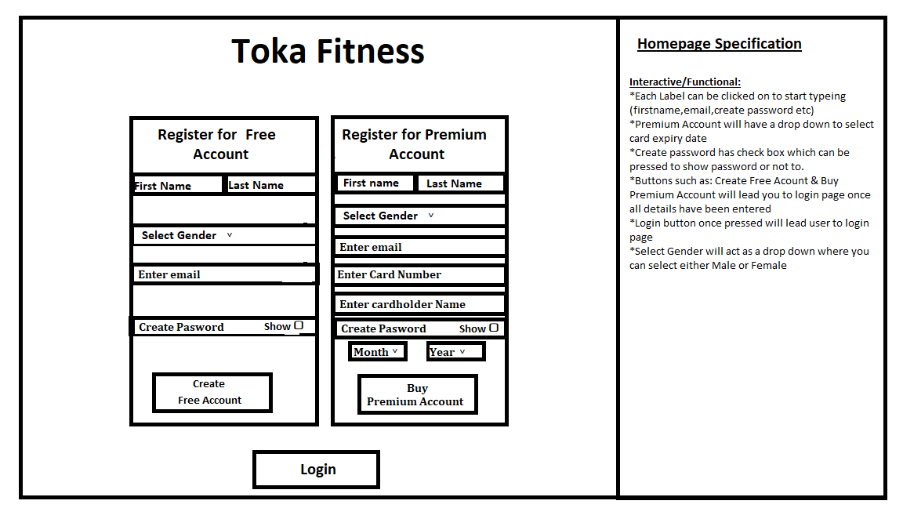**Register Screen**

**Login page**

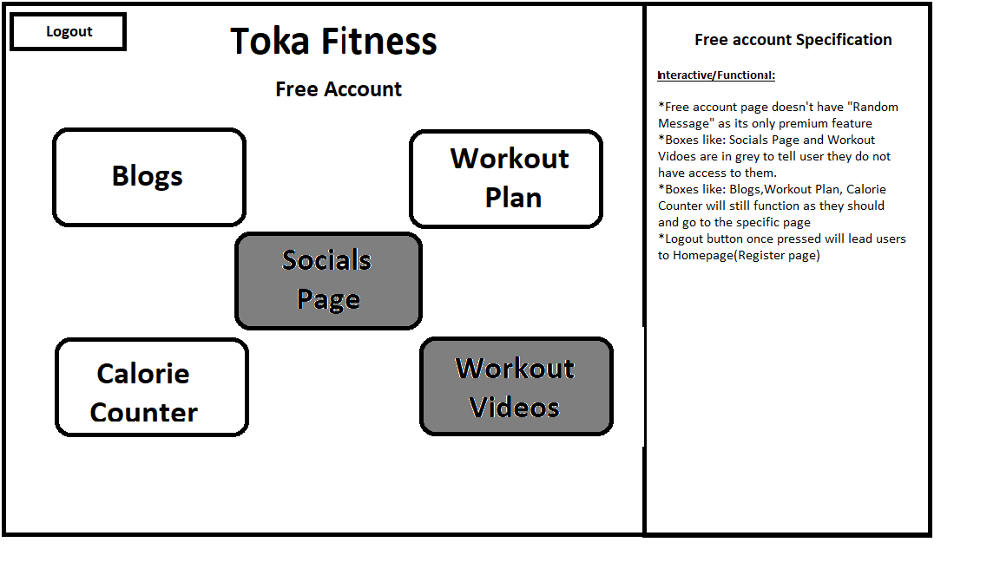**Free Account Page**

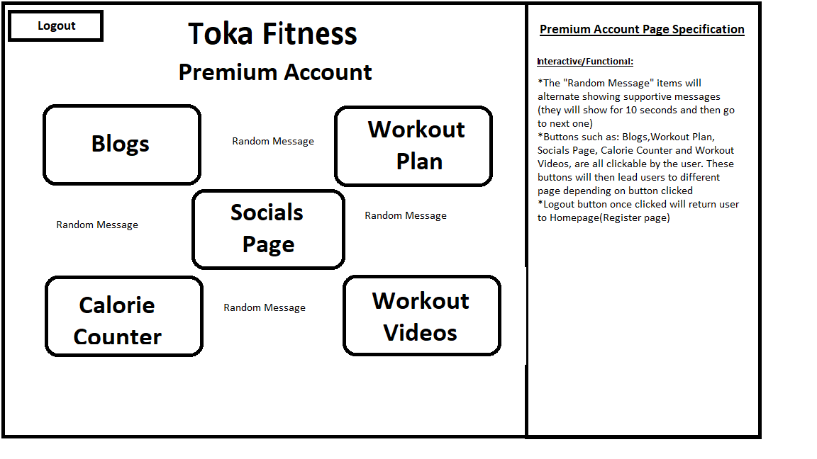 **Premium Account Page**

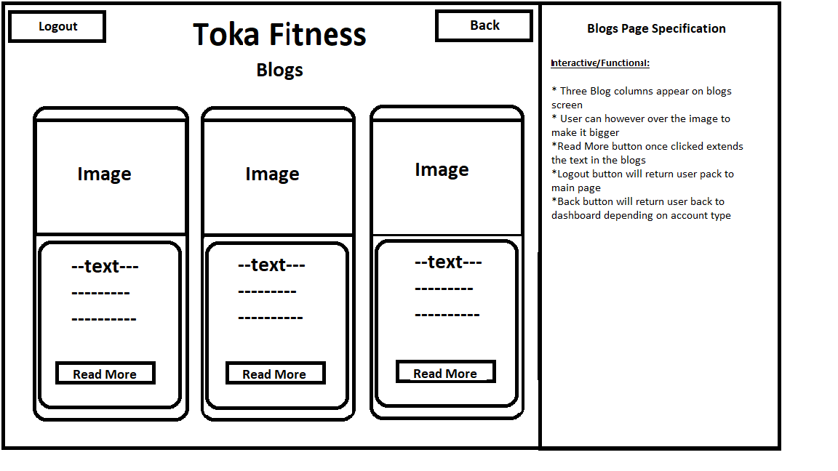 **Blogs Page**

**Workout Plan Page**

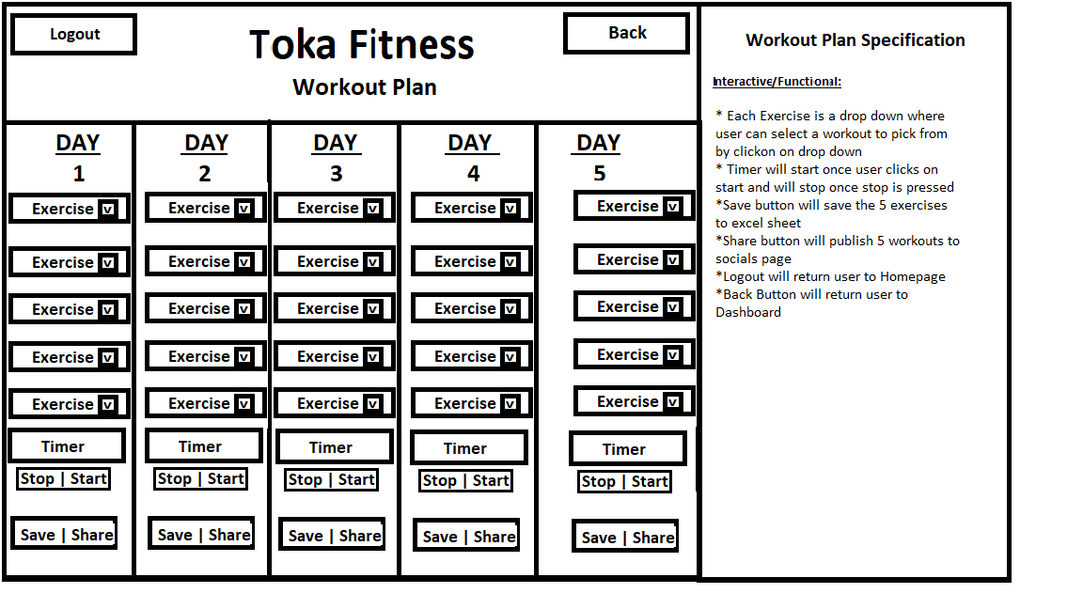

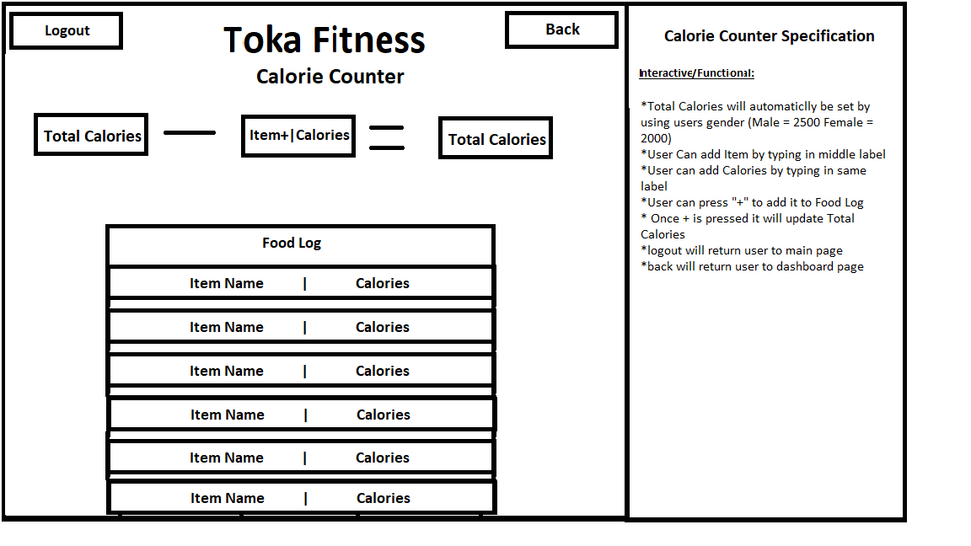**Calorie Counter**

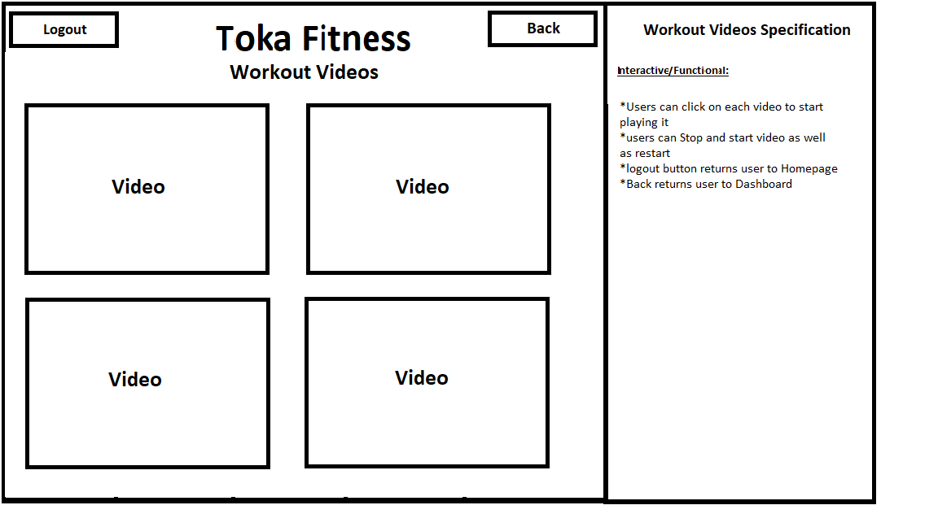**Workout Videos**

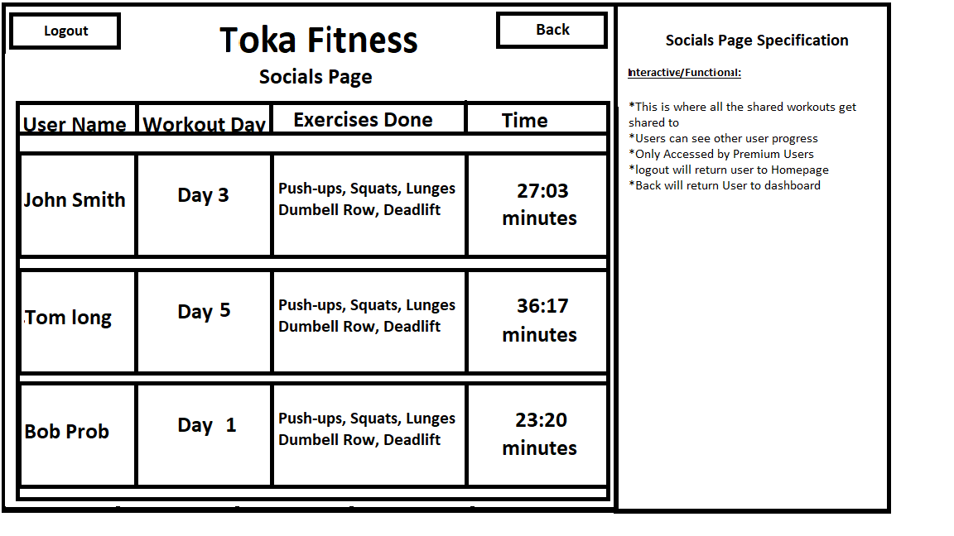 **Socials Page**

Wireframes

**Hierarchy diagram**



This is the layout of how everything would flow.

* User starts at homepage where they can register for premium or free account
* User is greeted with Login page where they have to enter details its asking them (login page will check for matching details between two excel files to see if it exists)
* If user Details Exist in either Excel Files ( Premium or Free) they will be sent to the dashboard they register for.
* Once user is sent to the dashboard, they will be greeted with either Premium Welcome or Free Welcome
* Free Dashboard Page will have 2 boxes greyed out meaning it’s not accessible for them and if they are however over it they should see a no entry sign pop up ( cant click on it)
* Premium Dashboard page will have full access to all the functionality unlike free doesn’t

**Data Requirements**

List of data collected/how it’ll be stored

|  |  |  |
| --- | --- | --- |
| Variable Name | Function | User Acceptance ( what it should do ) |
| Free_FirstName | Store Users name from Free registration form | Should contain users input being their first name |
| Free_LastName | Stores Users last name from Free registration form | Should contain users last name input |
| Free_Gender | Stores User Selected gender  Which also has assigned values such as Male containing number 2500 and Female contain 2000 | Once user selects the gender it will have value assigned and sent to csv file |
| Free_Email | Stores Users email | Users email will be stored |
| Free_Password | Storing Users Password | Users Password will be stored |
| All the Variables about will be the same for Premium account registration but instead of Free_ it will have Premium_ (To shorten number of variables) Example: Premium_Gender,Premium_Password etc | | |
| Card_Number | Stores all characters entered in card number | Stores information (only numbers) |
| Cardholder_name | Stores all characters entered in cardholder name | Stores Information |
| Expiry_Month | Dropdown which stores all 12 months and can be selected | Stores 12 months for expiry date |
| Expiry_Year | Dropdown which stores years from 2022-onwards | Stores years from 2022 onwards |
| Check_ Expiry_Month | Checks if item has been selected from drop down by looking at the value chosen | Check against Expiry_Month veriable and if selected item is on it |
| Check_ Expiry_Year | Checks if item has been selected from drop down by looking at the value chosen | Check against Expiry_Year veriable and if selected item is on it |
| Check_Card_Number | Checks if Card number only contains numbers and no letters as well as the length of card number if it’s over 1 its acceptable and if under 16 it’s not acceptable | Will verify if the number entered is what its supposed to be like checking length and items inside it |
| Check_Cardholder_name | Checks if card holder name has been entered and doesn’t contain any numbers or special characters in it | Makes such that name entered follows all the rules such as only containing the length and no numbers inside it |
| Check_FirstName_LastName | Has preassigned values to check against such as length check | This will be used as a check requirement to see if user has entered their name by checking the length if its more than 1 they entered their name else if its below 1 they have not entered and therefore will have a message returned saying to fill it in again |
| Check_Gender_Chosen | Checks if item has been selected from drop down | Will look for item in drop down and if when submitted form it doesn’t contain gender either male or female it will ask to fill it in |
| Check_Email | Has special character assigned to it such as “@” which will check if email has @ symbol | Once email is submitted it will see if email variable contains @ symbol |
| Check_Password | Checks if password has all the required items such as if its been filled in, contain special character: “!?£$%&”, checks if length of password is more than 8 | Once form is submitted the password will have to go thought and check if it has any of the required items to proceed. |
| More variables will be set in the future while working through the project, This is only for the registration page and checking if everything entered is how its suppose to look like | | |

**Algorithm Designs**

flowcharts (algorithmic thinking) User Registering For Free Account





User sharing their workout on socials

Pseudo code

**Login if details match within csv file**

OPEN csv file as a list //opens csv file as a list

SET Find_Login as a list with csv file // Find_Login variable is now holding the csv file as a list

Set LastName_Found as a list //Creating Blank Lists

Set Password_Found as a list //Creating Blank Lists

FOR row in csv file // for row in csv file

Add row 0 to LastName_Found // add row 0 (it contains users Last Names from register) to variable LastName_Found

Add row 1 to Password_Found// add row 1 (it contains users Passwords from register) to variable Password_Found

For items in LastName_Found // for items in LastName_Found ( contains user last names)

SET LastName_Found as LastName //creating new variable LastName which has all information LastName_Found had

IF LastName equals userINPUT AND Password_Found equals userPassword // checks if LastName matches users input (Last Name) as well as If Password_found matches UsersPassword

Return Dashboard page // if it does it will return them to dashboard which has the details

END IF

END FOR

END FOR

**Reading from Csv file**

OPEN csv_file // opens csv fiel

SET csvReader as csv_file //csvReader veriable now contains the csv file

SET line_counter to 0 //sets liner counter to 0 (used in for loop to go through each line in excel)

FOR row in csvReader // for every row in the csvReader( which contains the file)

IF line_counter EQUALS 0 //if the lines read equals to 0

print “ User name is” add row item //prints user name/ Add row item(name)

Add + 1 to line_counter // increments liner counter by 1 telling it to read next line

print “row item” //prints names

add +1 to line_counter //increments line counter by 1

print “read through” add line_counter “lines” //shows how many lines have been read all together

END IF

END FOR

**Test Strategy (9)**

There are plenty of ways to test how each component should work however the main things I’ll be using is:

* Black Box Testing
* White Box Testing

**Black Box Testing**

Black box testing is mostly done by software testers or clients who don’t need to have knowledge of programming as its only testing the functions such as the interface or functionality and not seeing the actual code behind it. Advantages of Black box testing would be that it is least time consuming as its methods can be done by trial-and-error ways. It can also be called as external software testing as you can allow stakeholders like clients and customers test the features or “demos”.

Black box testing can be performed at multiple levels such as (10):

* unit testing
  + individual units or components are tested
* integration testing
  + individual software modules combined and tested together
* system testing
  + test how components interact all together in application
* acceptance testing
  + done by stakeholders(clients) to determine application meets needs and business processes
* boundary testing
  + testing between extreme ends or between smaller ends like minimum-minimum of the inputted values

**White Box Testing**

White Box testing is done by software developers as it requires to have knowledge of programming as well as how its implemented. White box testing is most time consuming as your developers would have to right the code and test it at the same time instead of letting someone else do it like software testers or clients and that’s why its referred as internal software testing.

White box testing can be performed at multiple levels such as:

* statement coverage
  + executing all statements at least once in the code
* path coverage
  + tests all possible situations in the program

**Difference between white box and black box testing**

* Black box testing is done without knowledge of program code or application meanwhile White Box is done with knowledge about the program/application
* Black box testing doesn’t require programming knowledge but White Box testing requires Programming Knowledge
* Black box testing goal to test behaviour of software while White box goal is to test internal operation system

**Test Strategy table**

|  |  |  |  |
| --- | --- | --- | --- |
| Components to be tested | Type of test to be carried out | Predicted result | User acceptance criteria |
| Free Account Dashboard having 2 Functions unavailable for use:  Socials Page, Workout Videos | Black Box – acceptance testing | If user tries to click on any of the two functions nothing should happen. If they however over the 2 boxes no entry sign will appear | User should not be able to visit Socials Page nor Workout Videos |
| Registration forms data is sent to excel and saved in the file | Black Box – Integration testing | Two components will be used for this:   * opening csv * Writing   First csv file will have to open so data can be written into it  Second part will be once user presses register it should write all their data into csv file and saving it | Once user enters all data into the form and is checked to make sure its correct, and user has clicked register it should open csv file and write all their data which is being asked on the form as well as being saved. |
| Share workout to socials page | Black box – Integration testing  - Acceptance testing | (Integrate)Data will have to be saved to csv file from each drop down, it should then be written to csv file which stores all workout information and then once pressed share button it should be read from csv file and written to socials page  (acceptance) User should be able to click on save button and share | Once user clicks on save data should be sent to the csv file and written in there.  Once user presses share button their workout progress should be sent to Socials Page from the csv file |
| Clickable functions in dashboard | Black box – Acceptance Testing | Premium users should be able to click on every function, but Free users unable for 2 | Premium users have access to the entire dashboard  Free users don’t have access to entire dashboard (2 functions) |
| Logout/Login buttons | Black box – Acceptance Testing | Once clicked Logout on any account and any pages user should be sent straight away to long page being (homepage)  Once clicked on Login button in homepage users should be greeted with a page which is requesting them for login details to get back into their accounts | User should be able to click logout to be greeted with Homepage  User should be able to click on the login page to get back into their accounts by completing the form |
| Credit card Details (card numbers) | Black box – boundary testing | There should be a limit on the number of digits you can enter in card number maximum being 16 and minimum being 16 as well | If user decides to enter number over 16 digits it will not allow them  If user decides to proceed with less than 16 digits in card number it should not work |
| Dashboards and their functions | Black box – System testing | When user is logged in and is on the dashboard if they decide to go on any page, it should respond and work which would suggest all the modules are working | User should be able to click on each function if they have access to it  User should not have any errors once pressed on a dashboard item. |
| Navigation from Register page – login page - dashboard | White box – Path coverage | As a developer i will have to make sure than paths from main registration screen can go lead to login screen and finishing at the dashboard | I should be able to register an account  Once i register i should have login page appear on my screen  Once i login i should see my dashboard |
| Register Buttons | Black box – acceptance testing | Once register button is clicked all data from user forms should be filled in the csv  Button leads to login page | User is able to click Register Button  User is then greeted with login page |
| Calorie calculator | Black box - unit testing  - integrated testing | Total calories should be read from csv file which been saved from gender selection drop down. Adding Items should be possible by writing its name and calories and by pressing + button should transfer all data to Food log. Added calories should be taken away from total calories and giving the answer of calories remaining | User can see that Total calories is dependent on their gender  User can add type in the item as well as their calories inside and submit it with a +  Once clicked + user should see the Food log table have the item they added  The calories in the food item they added will be taken away from total calories and result of Total calories left will update |
| Read more button ( blogs ) | Black box – unit testing  - acceptance testing | When clicked on read more button in blogs page more information should show up instead of the 1 sentence | User should be able to click “Read More”  User should see more content displayed once pressing button |
| Timer (Stop/Start) | Black box – unit testing | When clicked on start Timer should start from 00:00 and go up. Once pressed stopped timer will pause at the time showing on the screen | User should be able to Start the time  Timer should start incrementing by 1 second  User can stop timer by clicking stop button |
| Video | Black box – acceptance testing | Clicking on the video should start playing it, if clicked against should pause it | User can watch videos by clicking on them  User can pause video by clicking pause button and replay to watch again |
| User entering out of boundary numbers in card number label | Black box – boundary testing  - acceptance testing | Testing to make sure users cannot enter more data than is required too | User cannot type more than maximum allowance |
| User already existing when registering for account ( free and premium ) | Black box – acceptance testing | If two users enters identical information as an already existing customer, they should not be able to register.  This will be user to make sure no duplication is found within either excel files | User is unable to create another account with the exact same details existing in the data |
| In Task 2 these test cases will be tested throughout the development of the program. As a result of this there may be more tests added in the development to test more functions as well as testing the expected outcome and any errors which happened and how i fixed them. | | | |

**Citations**

|  |  |
| --- | --- |
| **Citations** | |
| **Links:** | **Number|what looked for** |
| <https://sworkit.com/> | (1) images have been gathered from this page as well as description of their product |
| <https://www.c25kfree.com/> | (2) images have been gathered from this page as well as description of their product |
| <https://www.myfitnesspal.com/> | (3) images have been gathered from this page as well as description of their product |
| <https://www.itproportal.com/features/top-10-essential-technology-trends-you-must-follow-in-2022/>  <https://www.techopedia.com/definition/34552/internet-of-behaviors-iob> | (4) Emerging Technology information been gathers for the research purposes |
| <https://www.altexsoft.com/blog/non-functional-requirements/> | (5) description of what non functional requirements is in brief |
| <https://gdpr.eu/> | (6) Rules of what laws come under GDPR |
| <https://www.nature.com/articles/s41377-021-00658-8> | (7) Emerging technology more information on visual reality (images also taken) |
| <https://www.wrike.com/agile-guide/benefits-of-agile/> | (8) Benefits of using Agile |
| <https://www.geeksforgeeks.org/differences-between-black-box-testing-vs-white-box-testing/> | (9) key deference’s between the two testing types |
| <https://www.whitesourcesoftware.com/resources/blog/black-box-testing/> | (10) more information on black box testing |